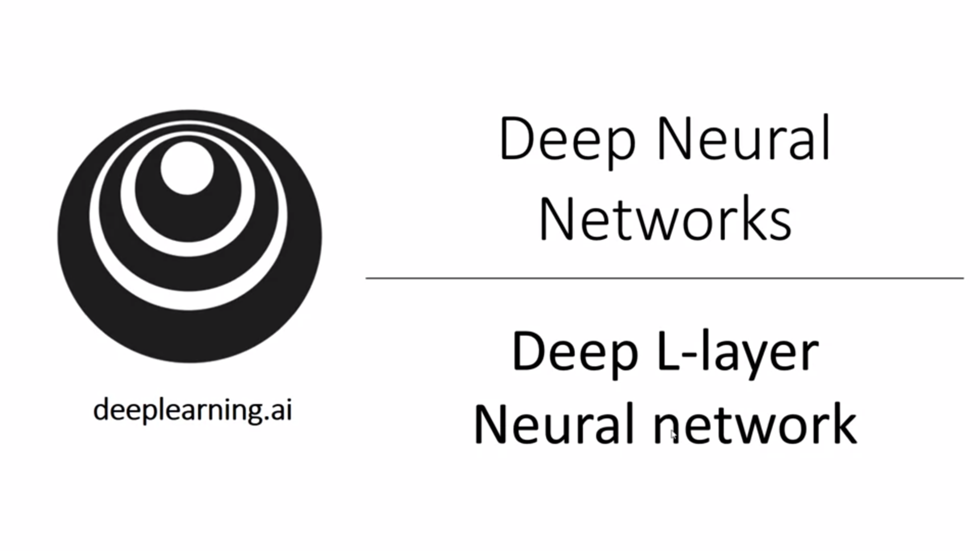

Take ideas from previous weeks and put them together.

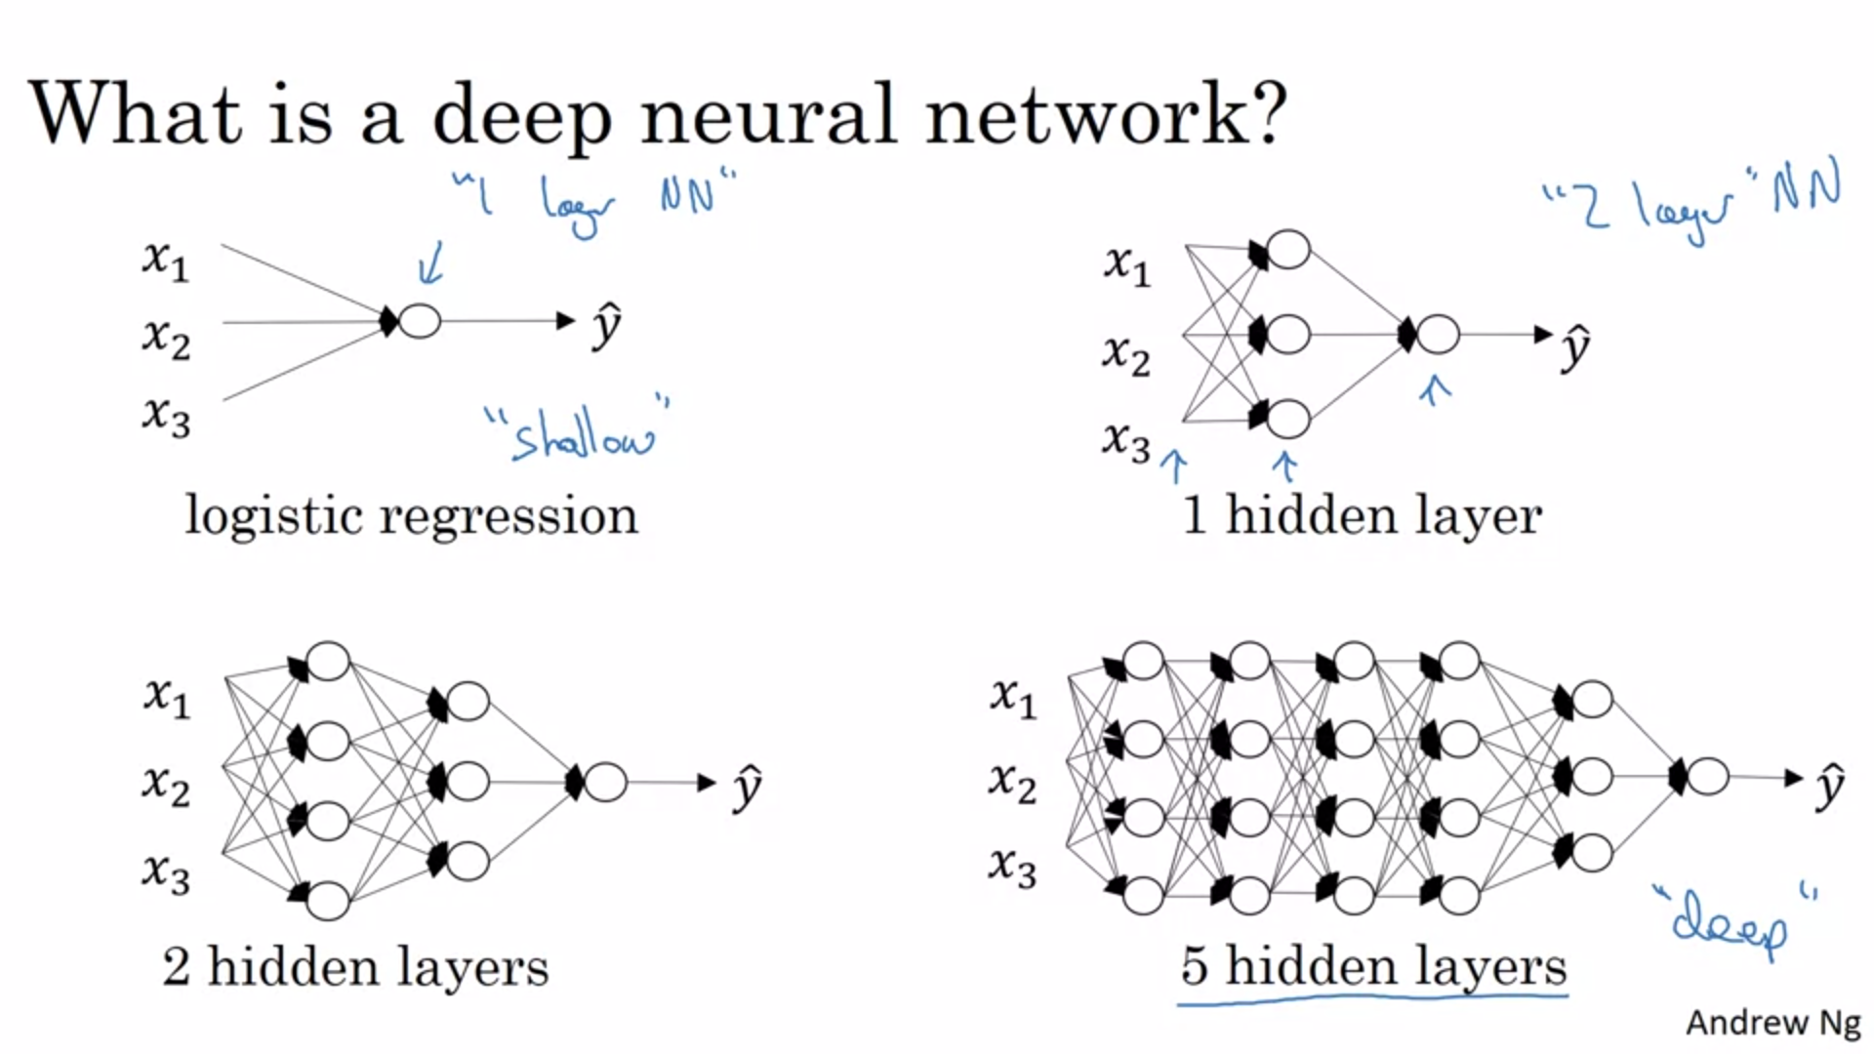

In the last couple of years the AI community has learned that there are functions that very deep neural networks can learn that shallow networks are not capable of. Slowly increase hidden layers as hyperparam and evaluate on dev set.

Let’s have a look at notation in a deep neural net:

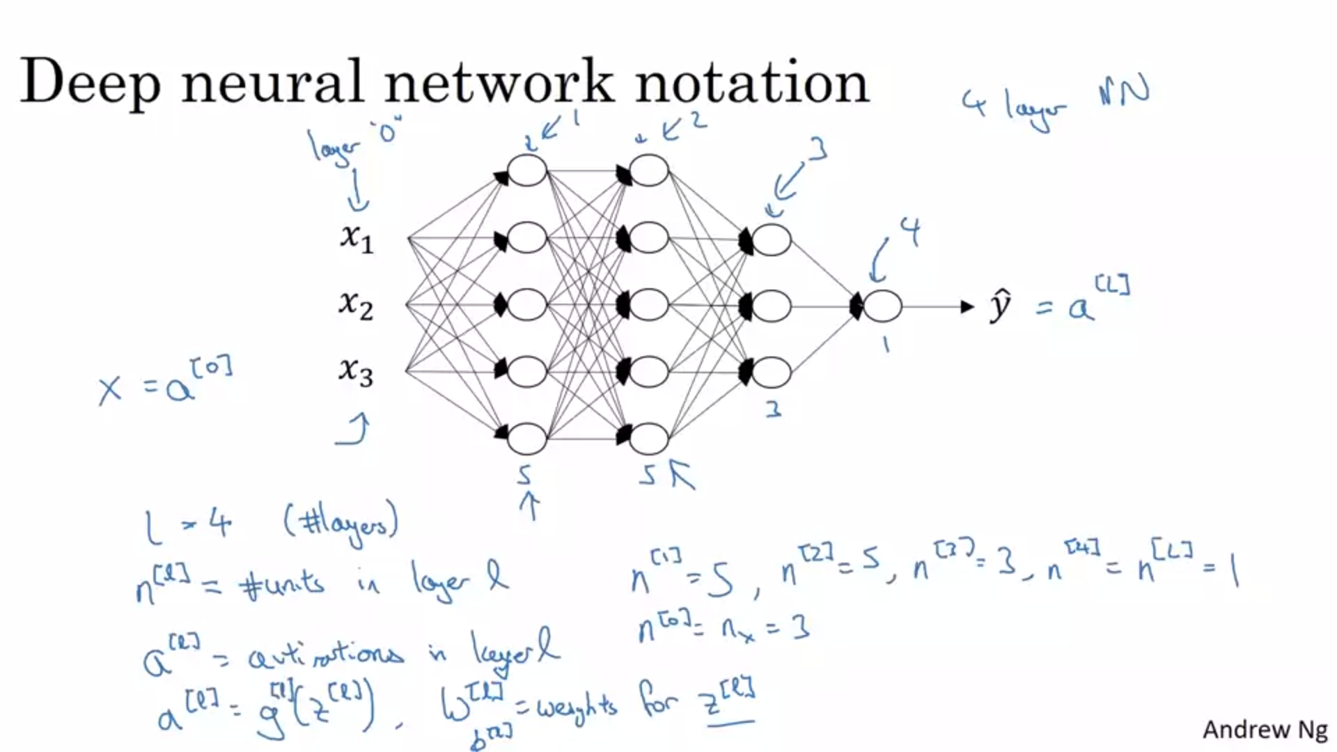

How does forward prop in this type of network look like?

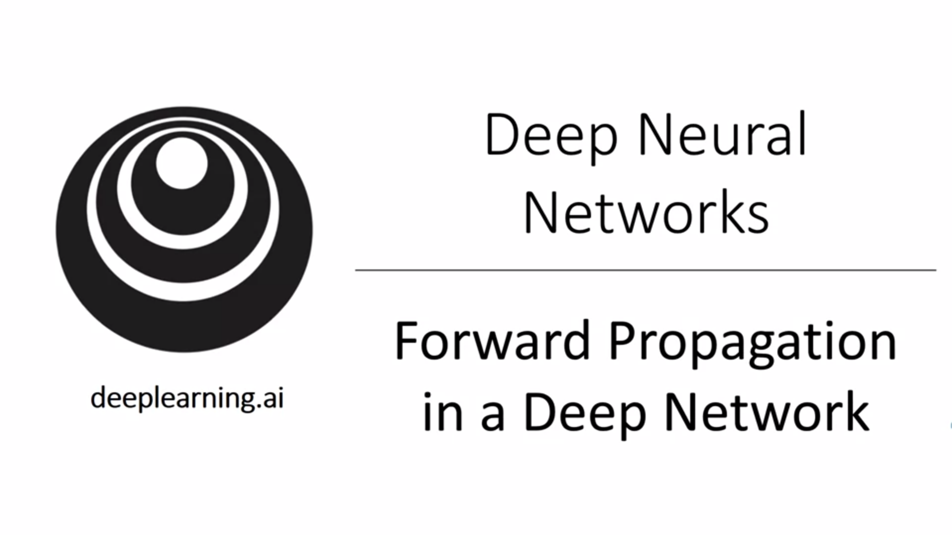

First let’s look at a single training example x, after we add vectorization. Uppercase is stacked (vectorized version). It looks like there is a for loop over the different layers l. There is no way to implement this without an explicit for loop.

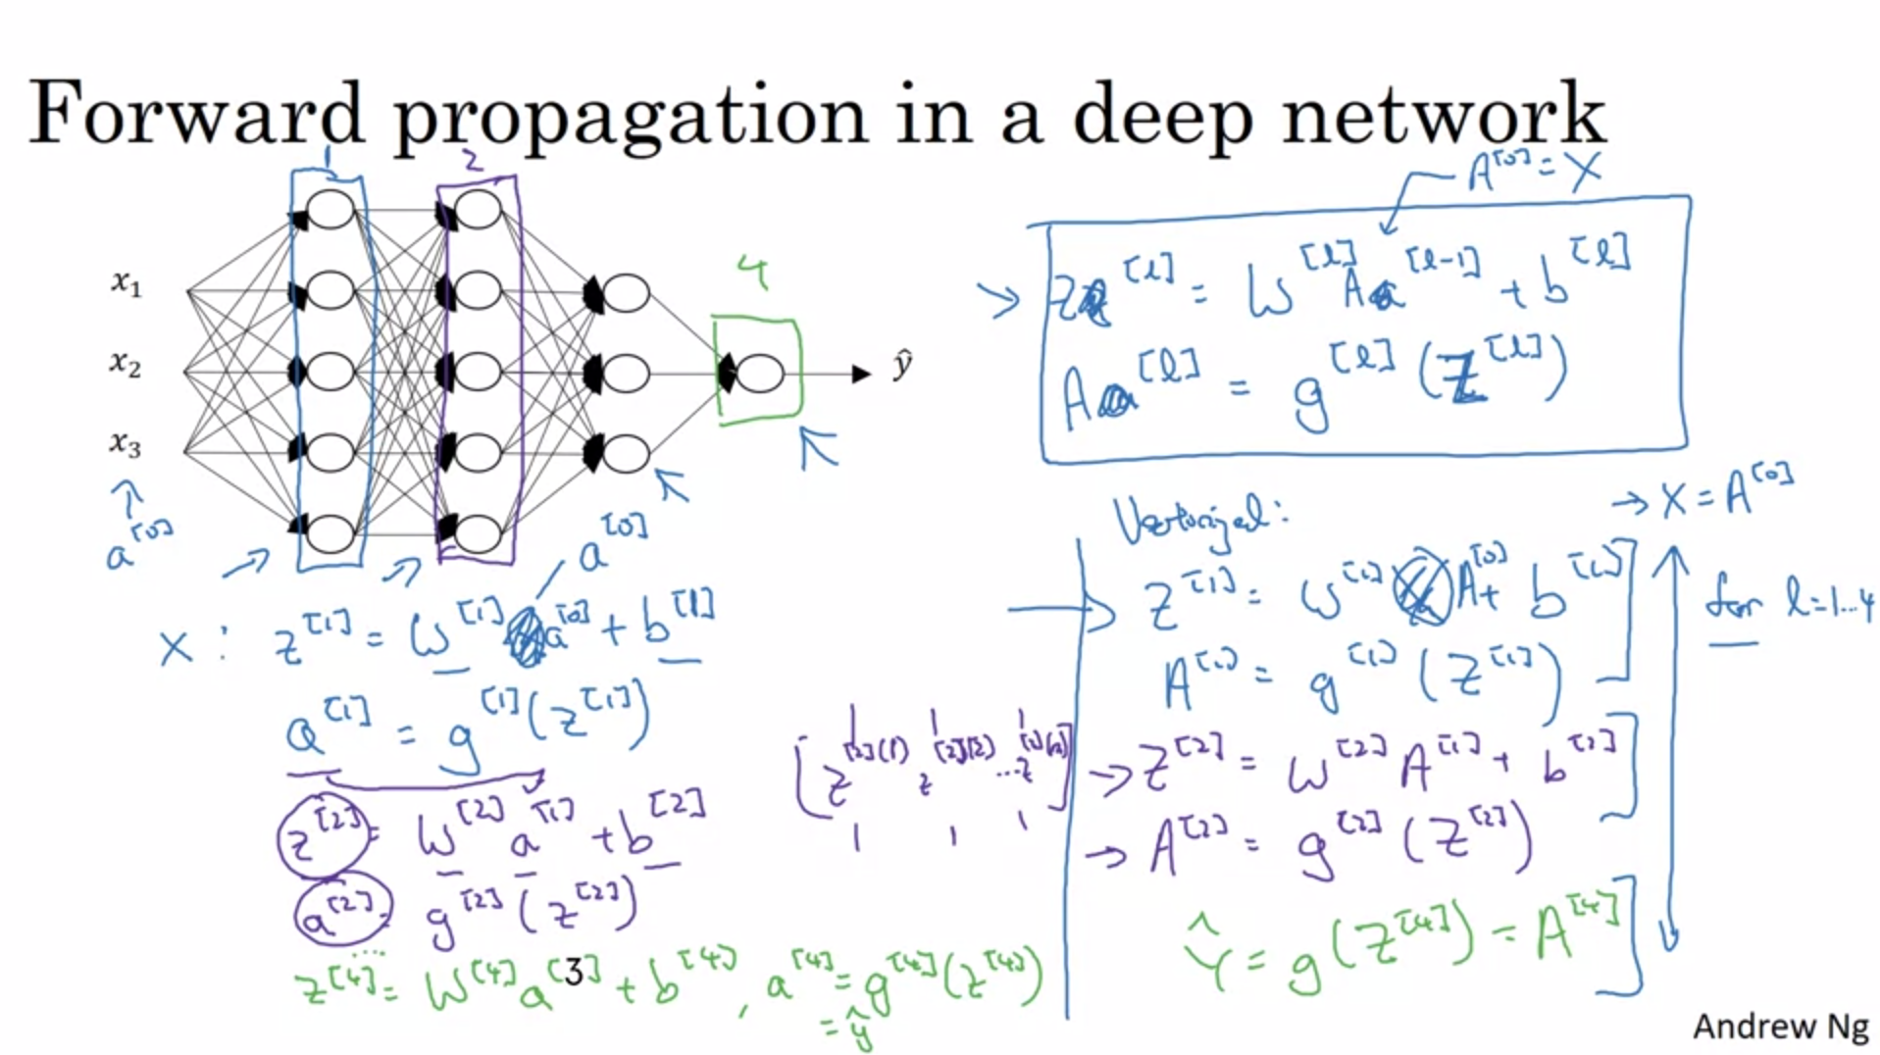

One of the ways to ensure bug-free implementation is to always check shapes!

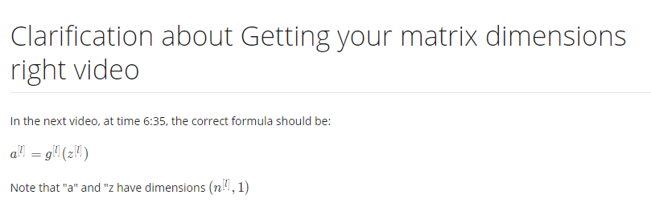

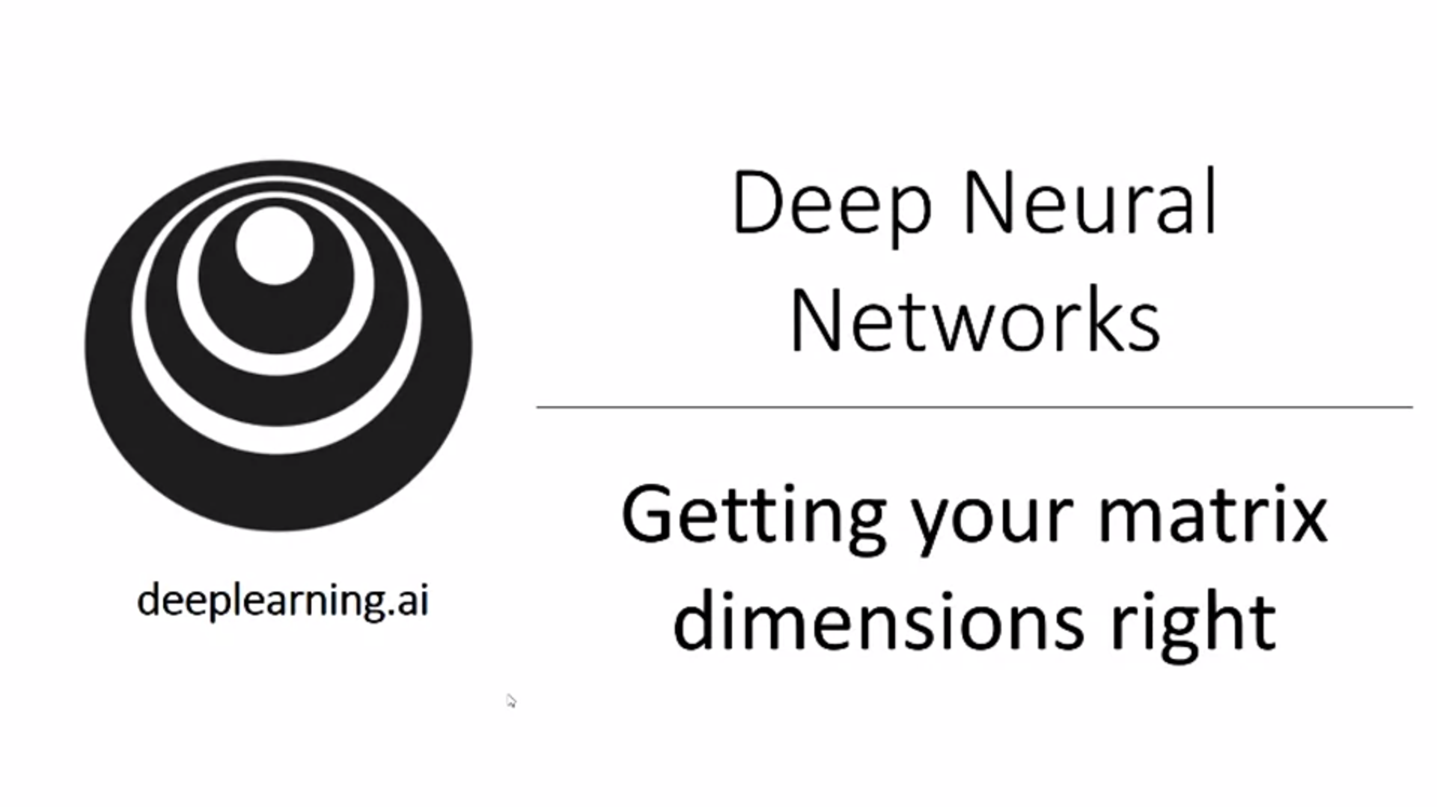

One of the debugging tools: Work through the shapes on a piece of paper.

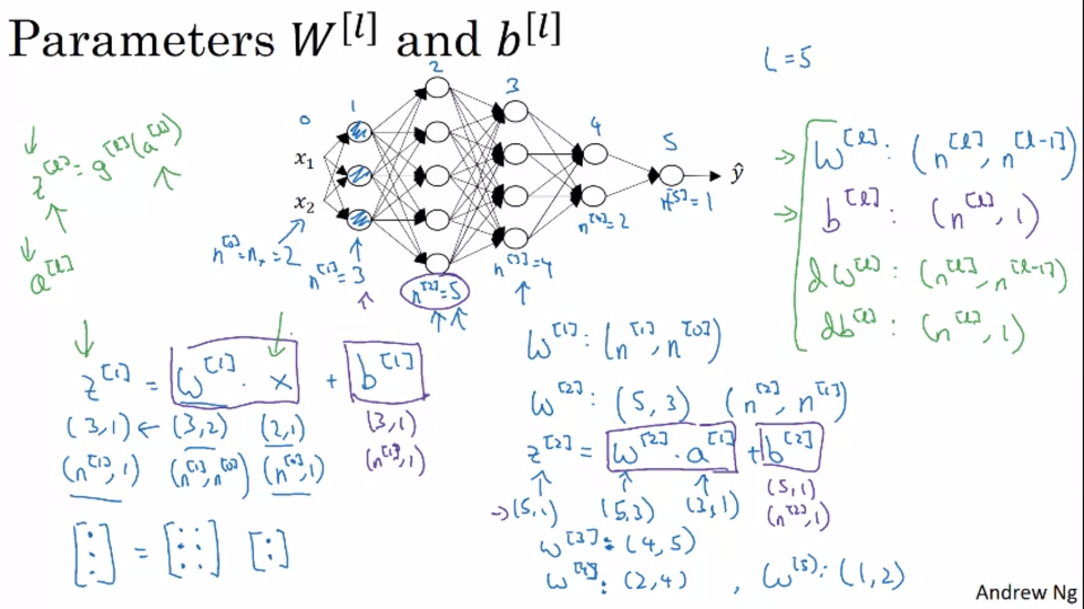

Later we will also talk about neural networks with multiple outputs.

Now let’s look at a vectorized version.

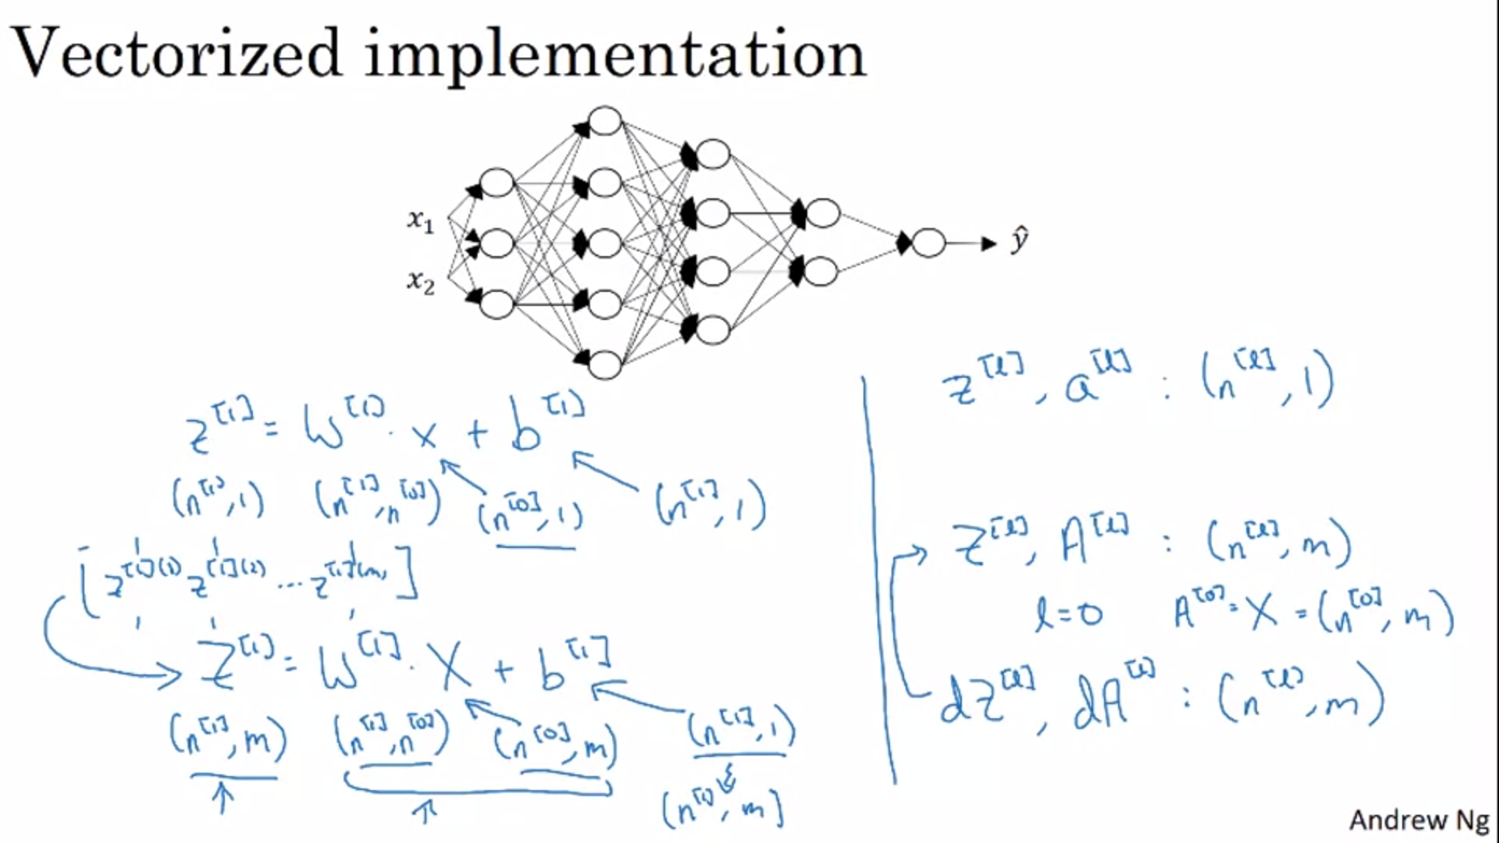

B will be Python broadcasted.

Why are deep neural networks so effective and why do they perform better than shallow neural networks?

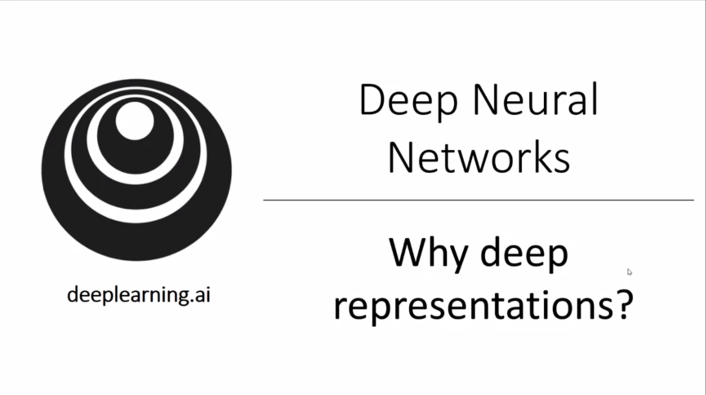

Neural networks need to be specifically deep (not big) to work well. They need to have a lot of hidden layers. Why is that? What is a deep neural network computing?

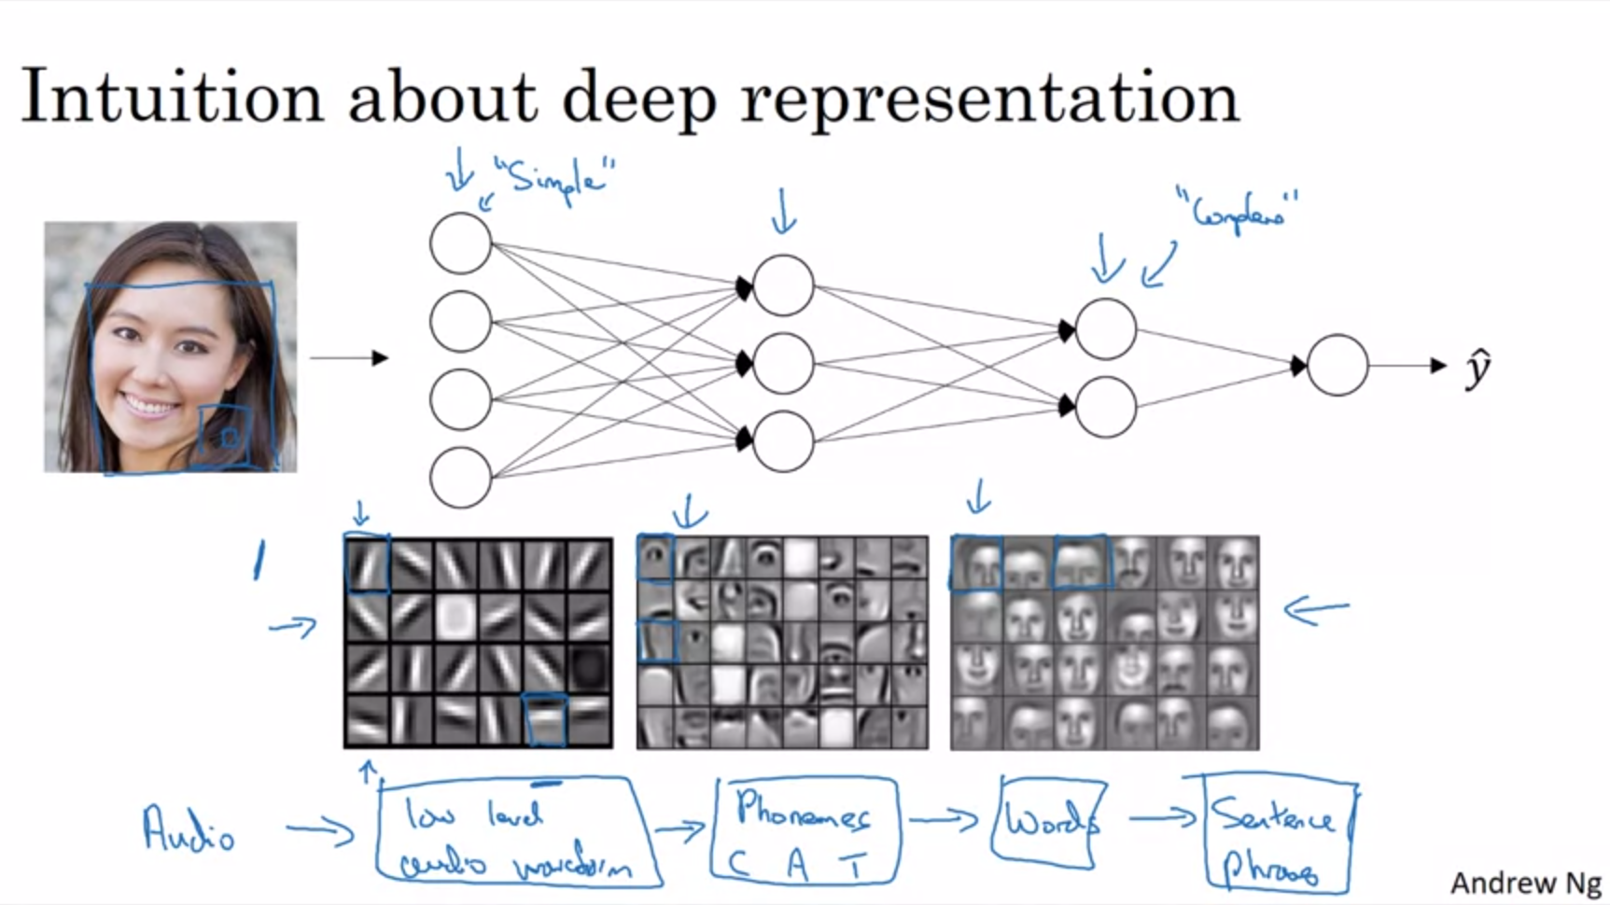

The first layer of the neural network you can think of as a feature detector / edge detector. The picture will make more sense when we look at convolutional neural nets later. The second layer starts to detect different parts of faces by putting together edges. The next layer could detect faces by putting together parts of faces.

Intuitively you can think of the earlier layers of a NN to detect simpler functions and then composing them together in the later layers.

Technical detail: the edge detectors look at small areas of the image, while the face part detector looks at bigger areas.

This intuition applies to other kind of data as well, not only images / faces.

Another example: speech recognition: Audio -> low level audio waveform (tone going up, down? white noise? what is the pitch?) -> by composing waveforms detect little units of sound (phonemes) -> by composing that together recognize words -> by composing that together recognize sentences.

By the time you get deep into the network you can actually do surprisingly complex things.

Some people like to make an analogy to the human brain (we also think the human brain first detects simpler things). Andrew thinks that these kinds of analogies are sometimes a bit dangerous but there is a lot of truth behind it.

The other piece of intuition why deep neural nets perform well comes from circuit theory (pertains to thinking about which functions can be computed through logic gates).

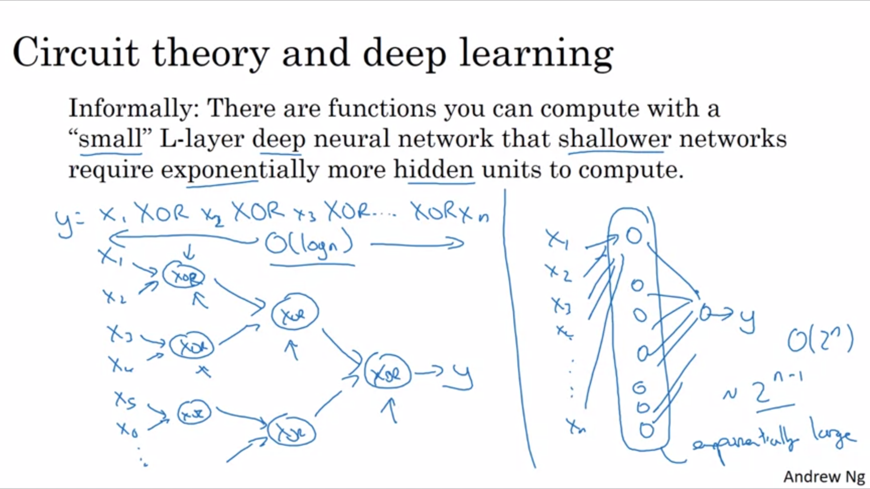

Example: exclusive or: with a deep neural net you can build this with quite a small circuit (order of log n). However, with a shallow neural net (1 hidden layer) it is quite more complex (order of 2^n). You need to exhaustively enumerate all possible 2^n combinations.

In addition to these reasons, there is also branding behind “deep learning”. The term really cought on and neural nets were rebranded.

Andrew often starts with a logistic regression or other simple NN to start off.

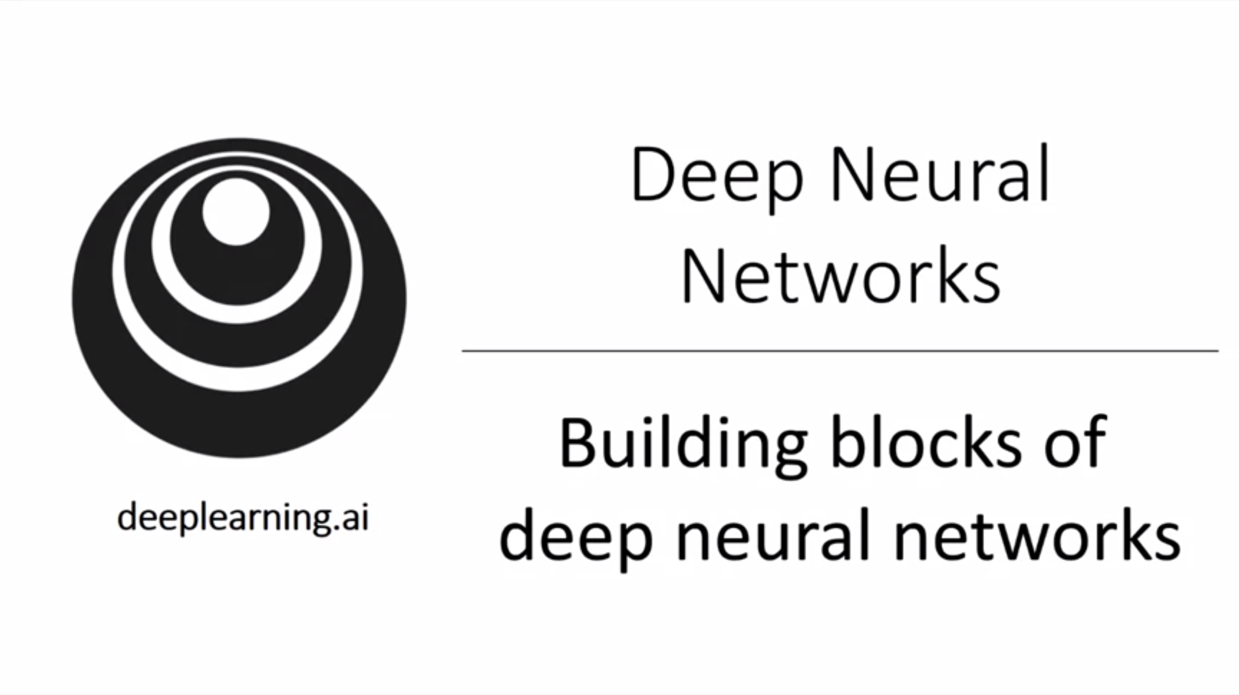

We have already seen the basic building block of forward and backward prop. How can we put these components together?

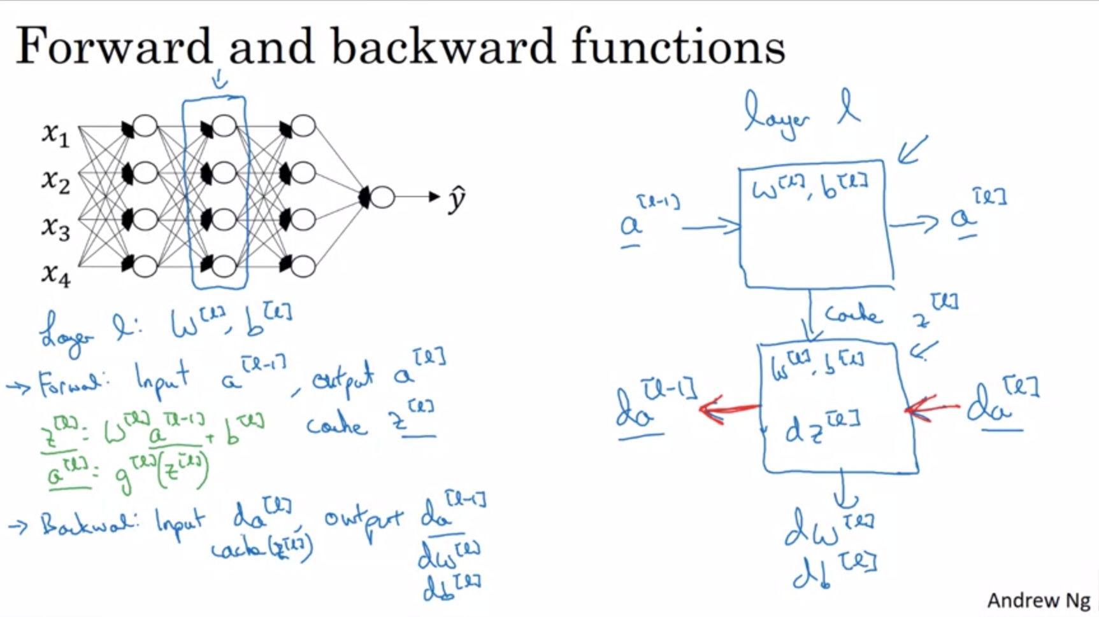

It will be useful to cache the things that are needed in backprop.

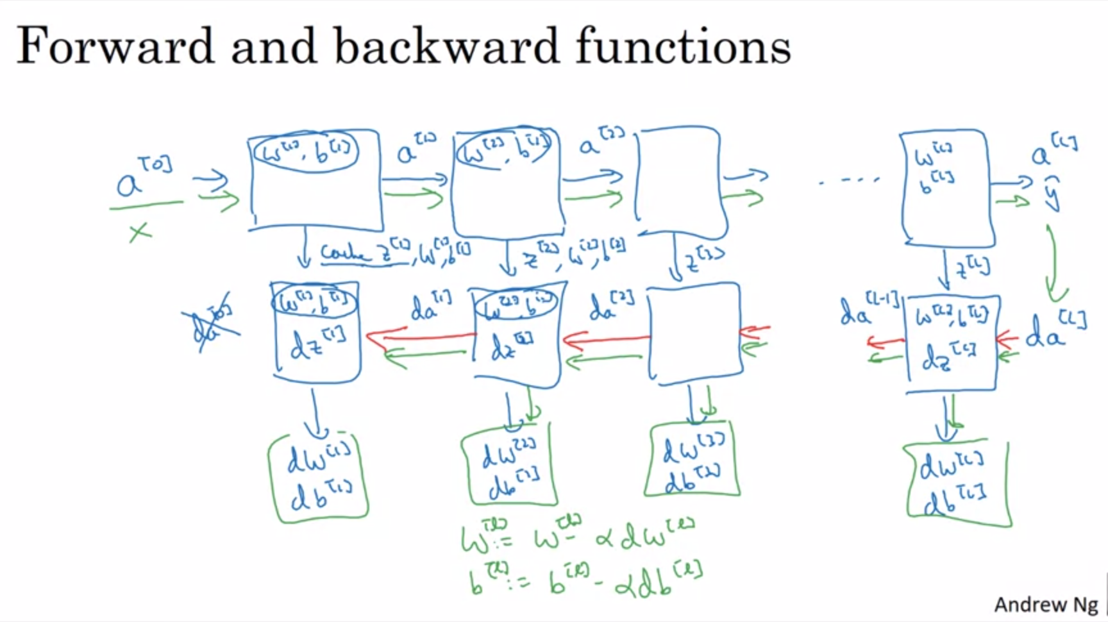

da[0] is not useful. All the derivatives we need are the dw’s and db’s.

One iteration of gradient descent training involves starting with a[0], doing forward prop and then doing backward prop and updating the parameters with gradient descent using the computed derivatives.

In the programming exercise W and b are also stored in the cache (convenient way to use them in backprop).

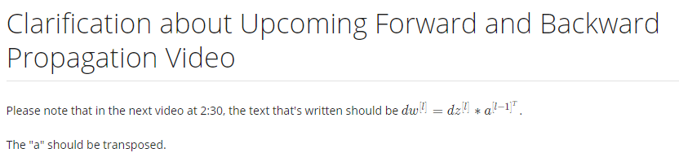

Now we will see how to actually implement forward and backward prop.

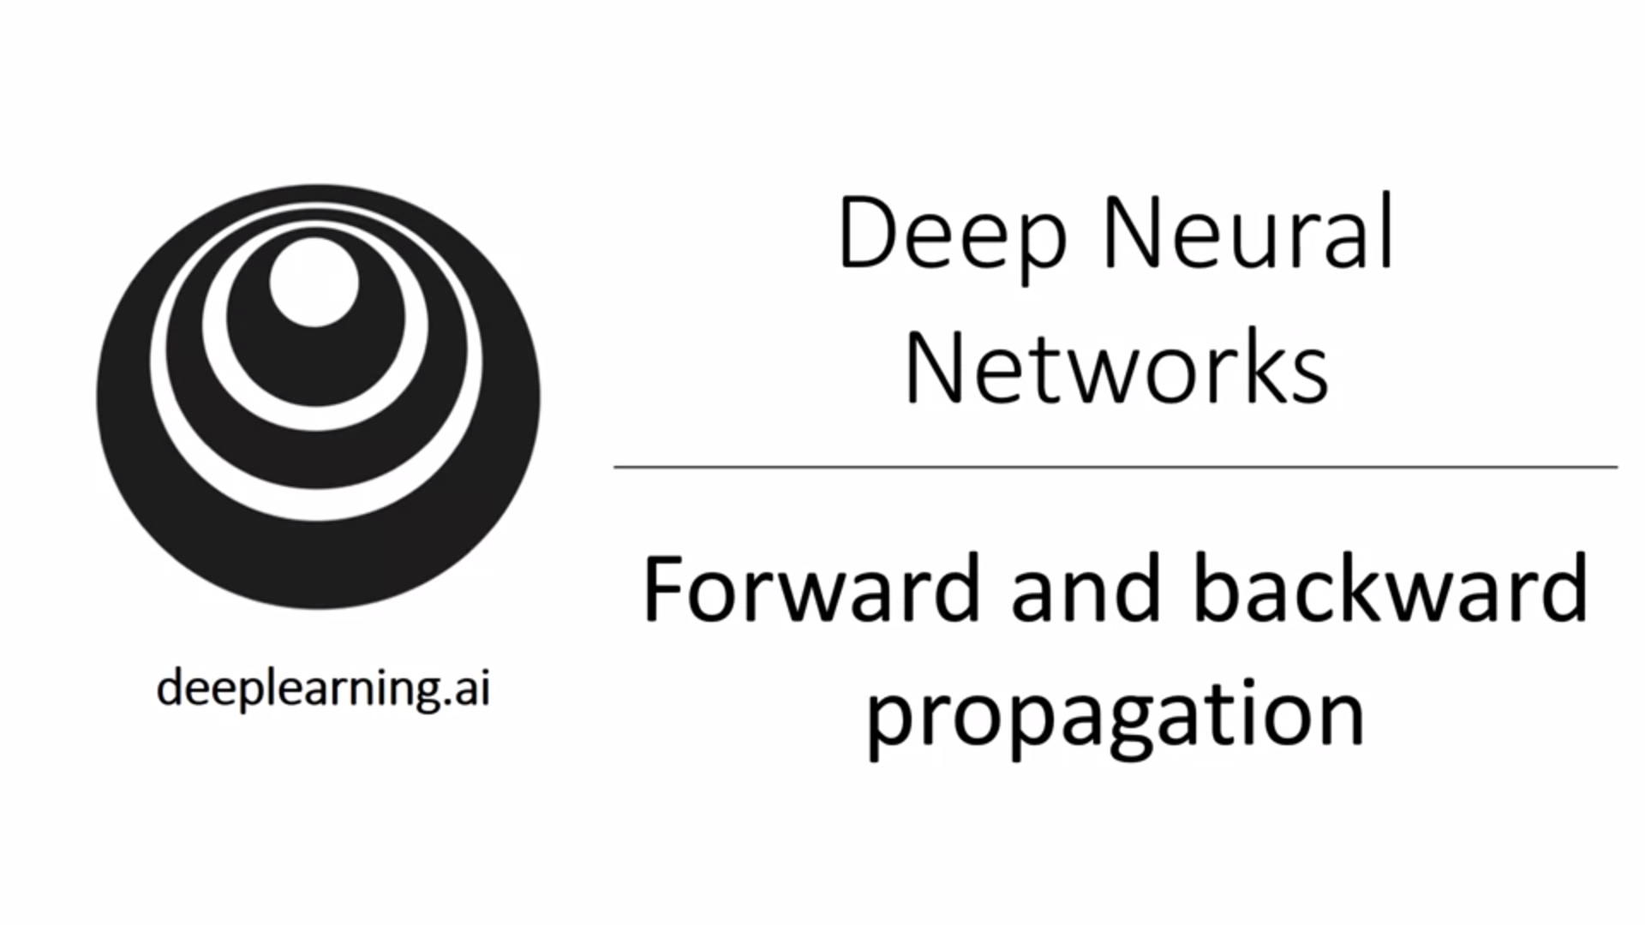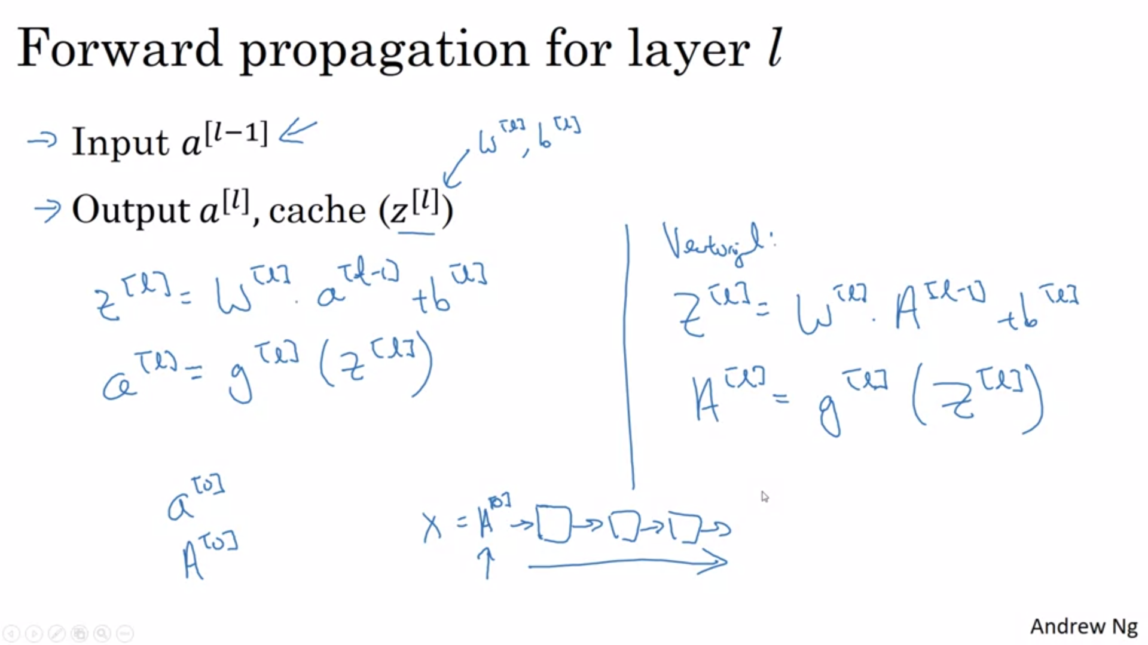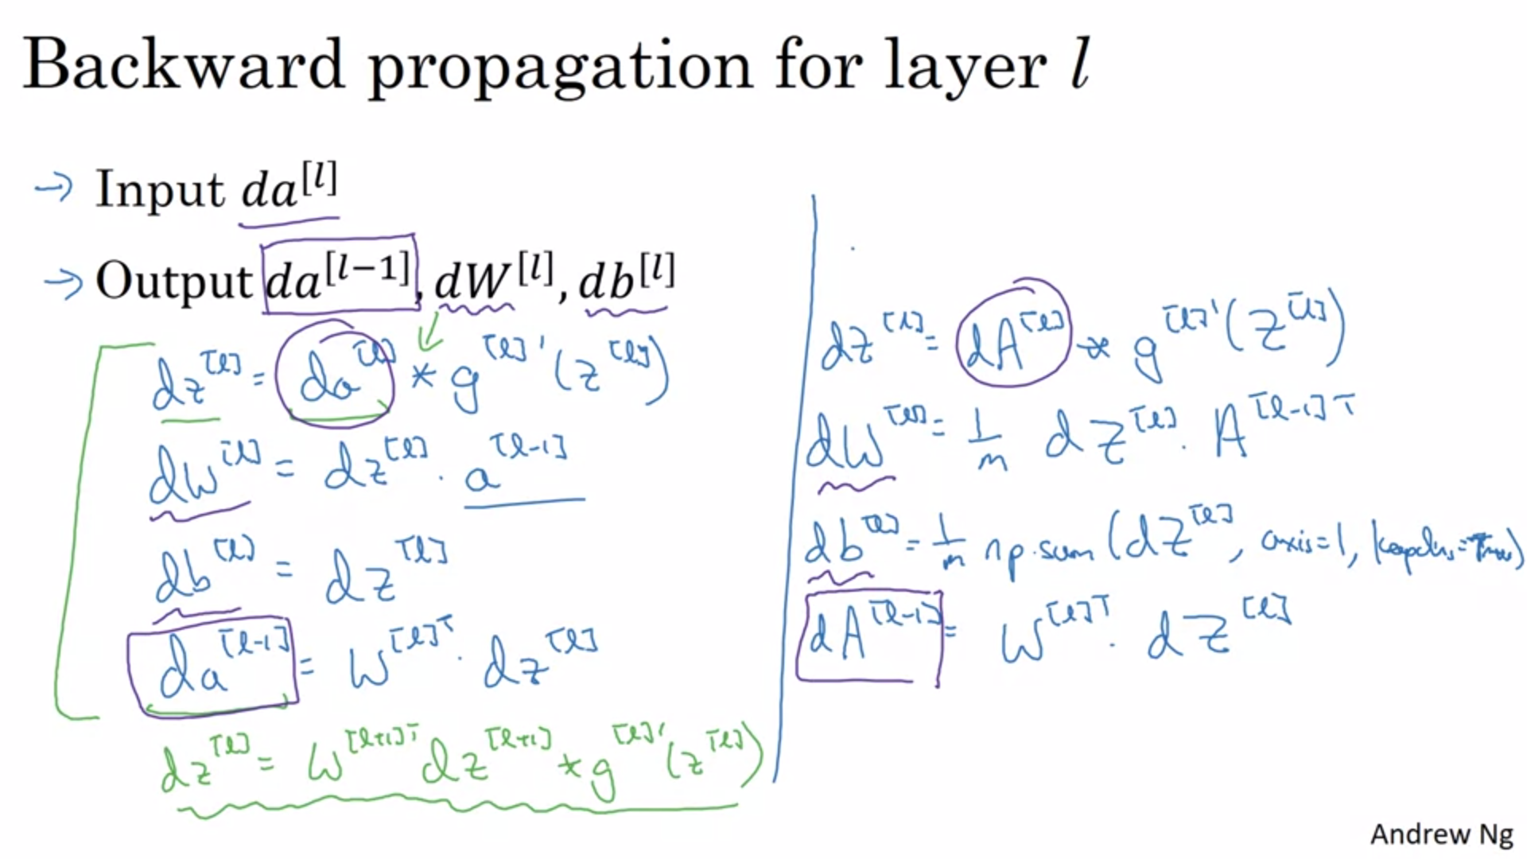

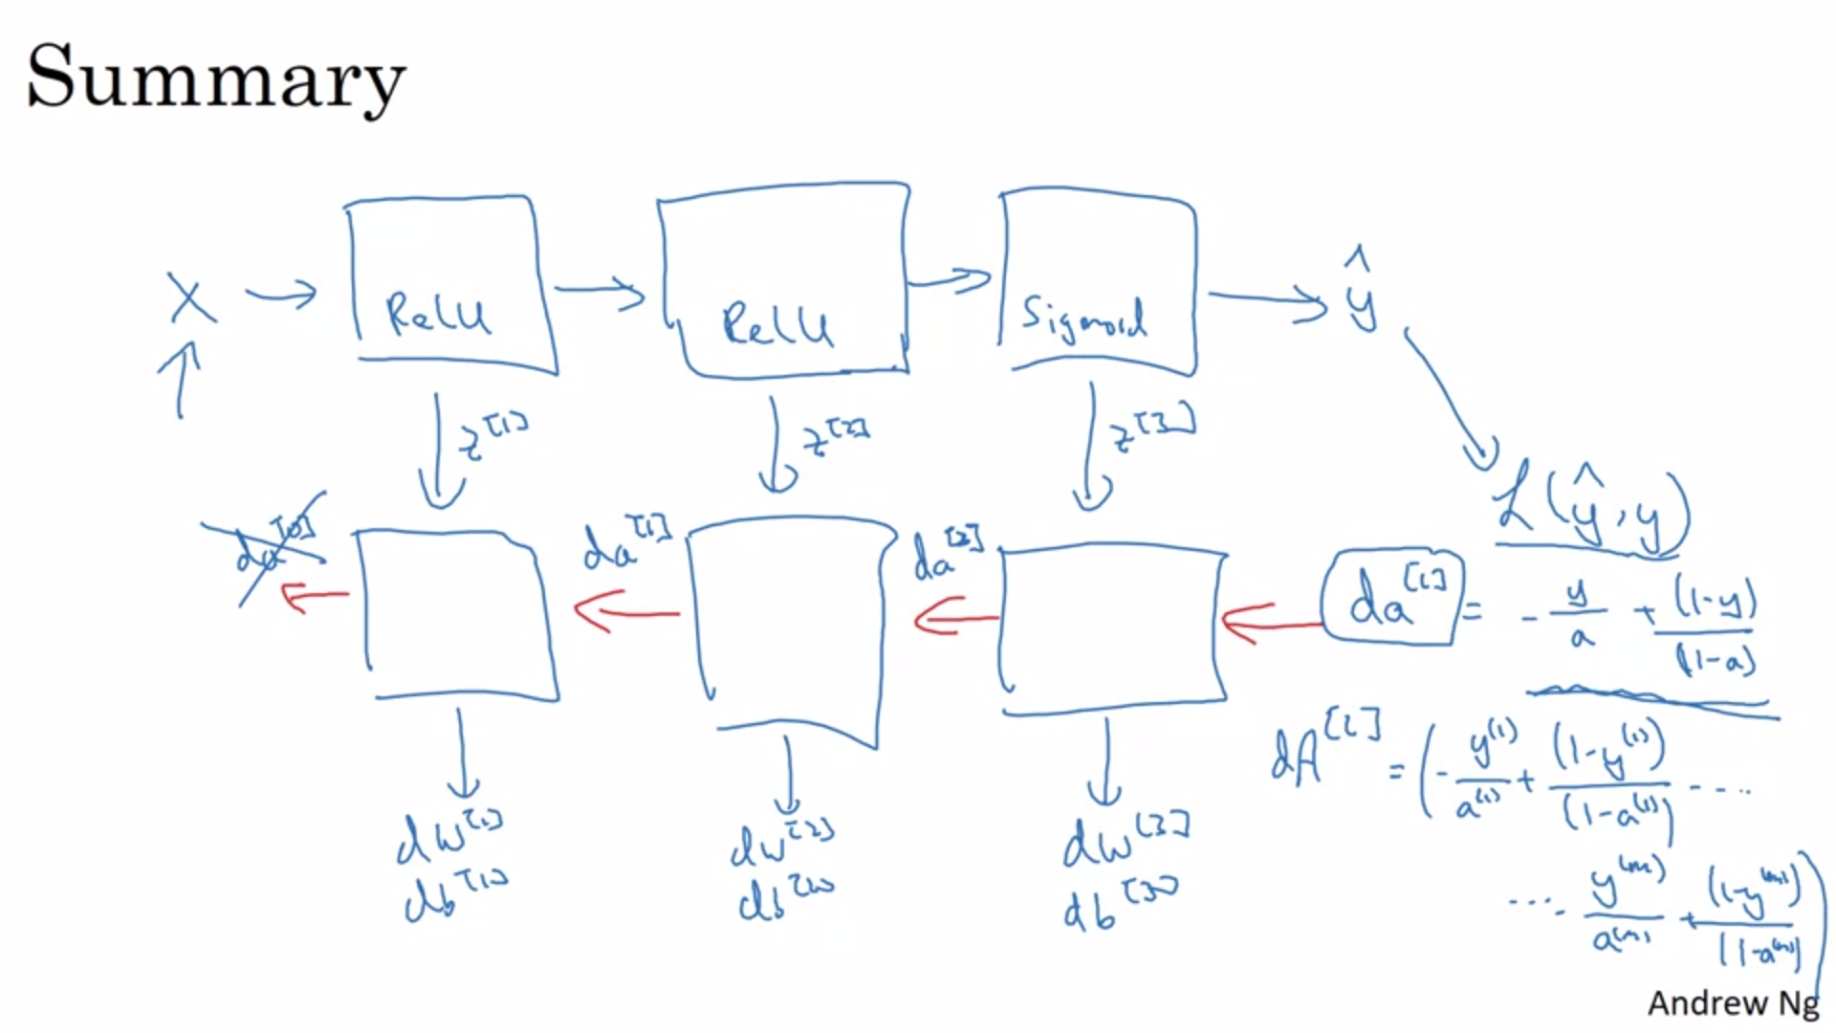

The backward pass is initialized with the derivative of the loss function.

A lot of complexity in machine learning comes from the data, not from the code.

Being able to organize hyperparameter search well will help you to be more efficient when creating neural networks.

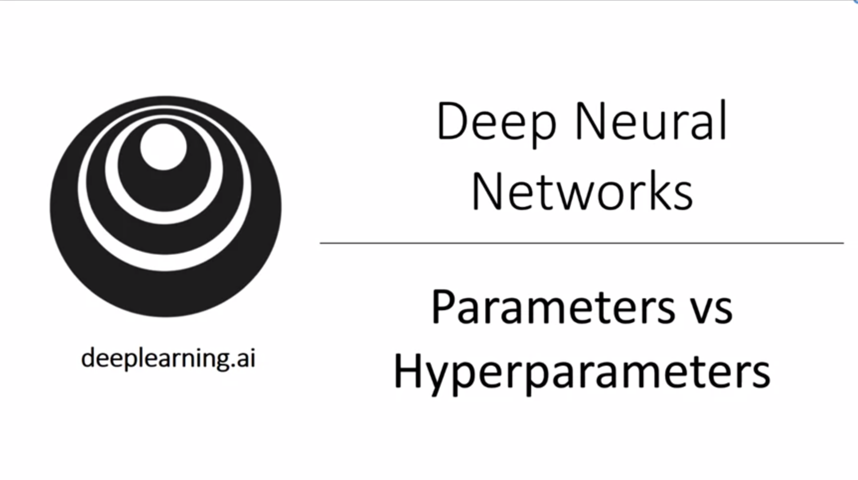

What are hyperparameters? Things that you need to tell your learning algorithm. “Parameters that control the ultimate parameters”

Deep learning has a lot of different hyperparameters. We will see more later.

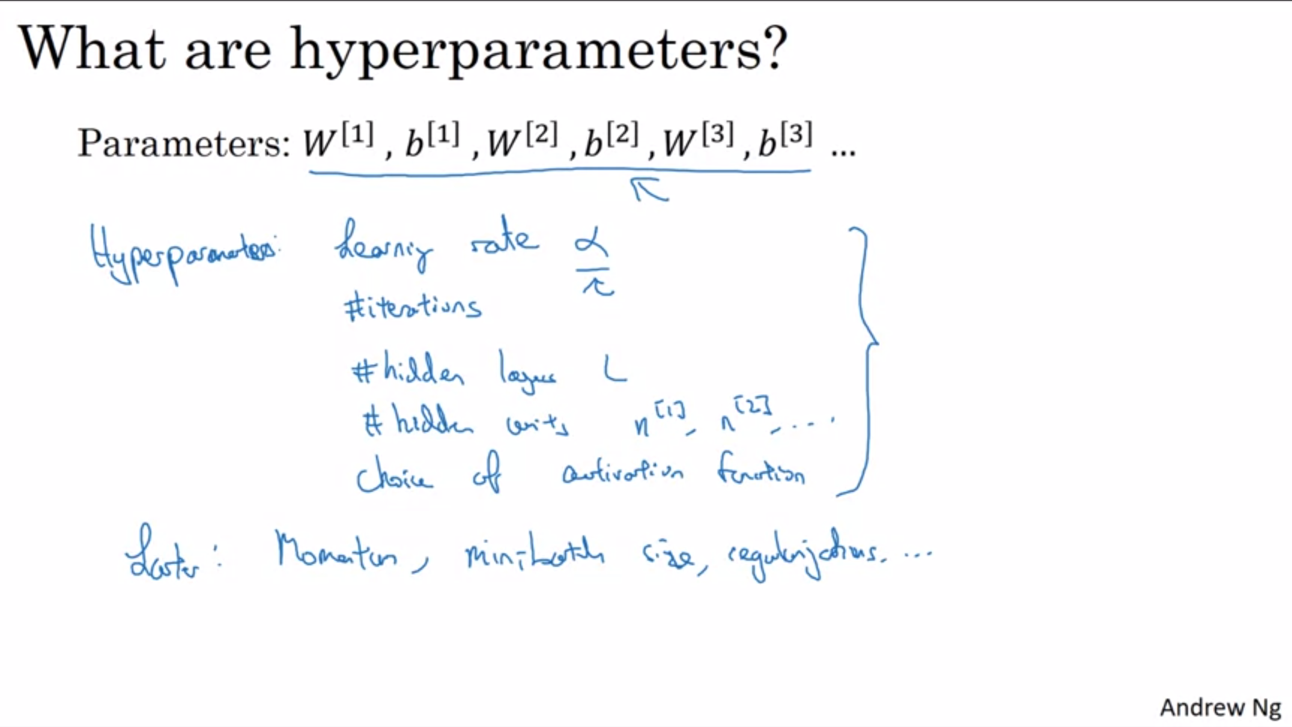

Applied deep learning today is a very empirical process. There are lots of different settings for hyperparameters. You will want to try out ideas and iterate depending on the outcome. Looking at the cost function to assess hyperparameters.

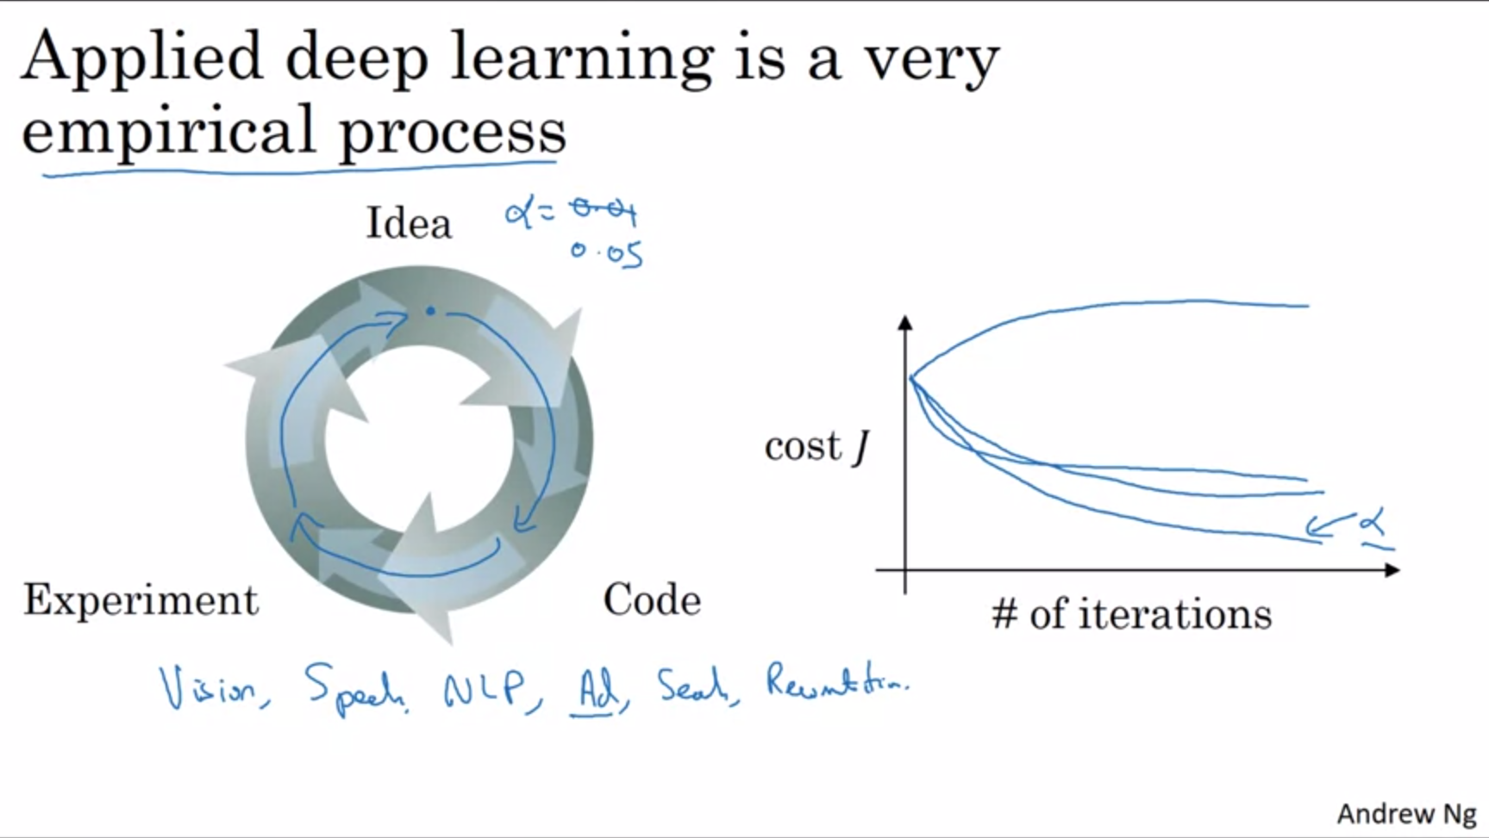

Empirical process is just a fancy term for “trying and seeing what works”.

Sometimes intuitions about hyperparameters carry over from one problem to another, sometimes not. Even within one application the best value for hyperparameters might change over time (for example if infrastructure, GPU has changed).

Probably the guidance won’t converge for now as hardware etc is changing at such a rapid pace.

In the second course we will look at some systematic way to search the space of hyperparameters.

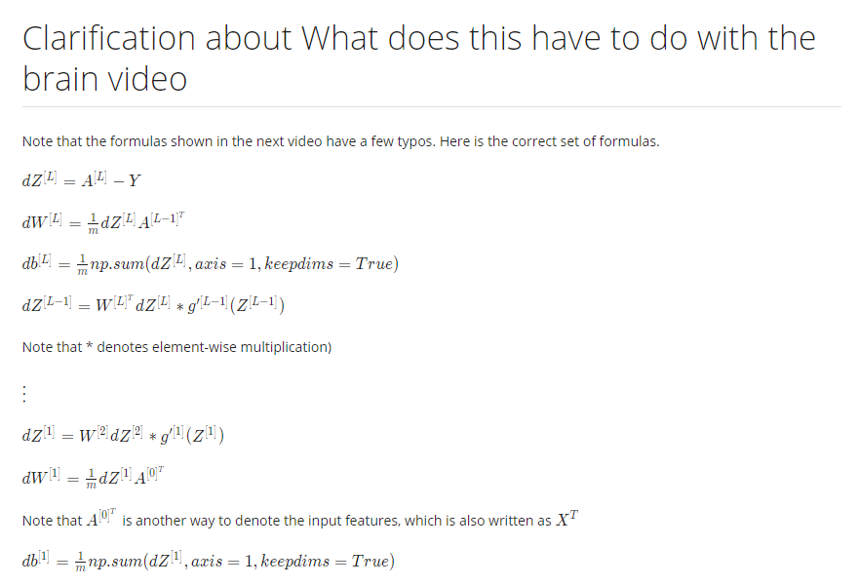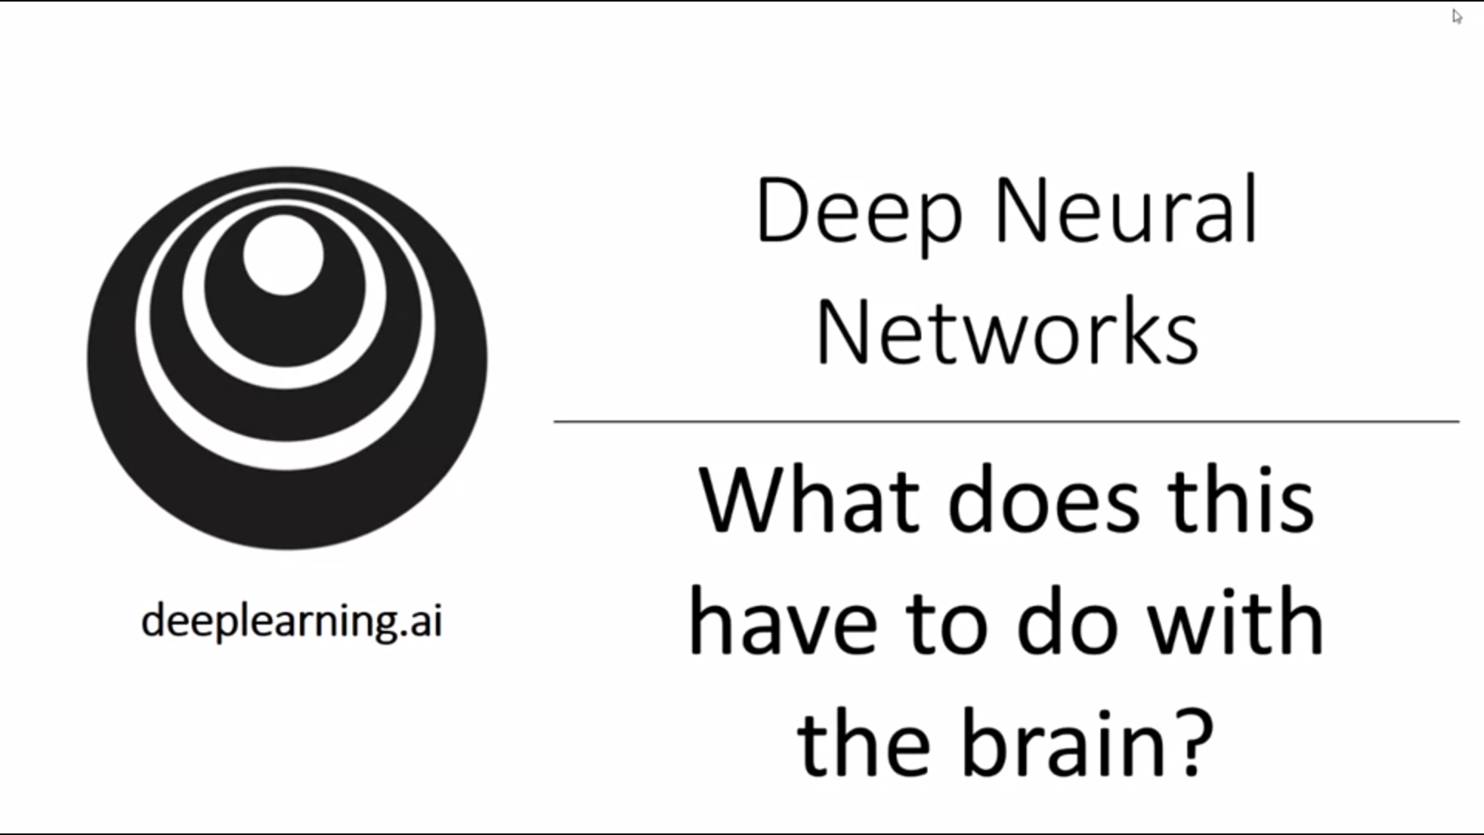

Andrew thinks not a whole lot. But why do people keep making the analogy?

It has been difficult to conveying what gradient descent is doing. “It’s like the brain” has become an oversimplified explanation.

There is a loose analogy though.

Neuron receives electric signals from other neurons. If it fires it sends a pulse of electricity along the axon to another neuron.

Even today neuroscientists do not have a good idea about what a single neuron is doing.

It is completely unclear whether the human brain uses a learning principle similar to gradient descent.

Andrew thinks of deep learning as very good at learning very complex functions to map from x to y.

